Infection control form for social and health care personnel
This form is intended for new social welfare and health care employees and students in the wellbeing services counties of Southwest Finland and Satakunta to evaluate the risks of infection. The personell fills this out this form from Intranet. The form is available in occupational health care -site. The students fills out this paper form. The form has been updated on 21 March 2025.

This form is divided in two parts.

The first part includes a tuberculosis and salmonella risk assessment and risk management guidelines for hand skin defects and multi-resistant microbial carriage.

The second part is to familiarise oneself with and assess the need to supplement one's own vaccination coverage. The assessment of the need for vaccination coverage is carried out on medical grounds for each location and task.

The employee/student should familiarise themselves with this guideline from the point of their own safety and patient safety. The employee's/student's health information asked in this form will not be passed on to the employer. All the mentioned guidelines are also valid during the employment/training period, and the employee/student can contact the occupational or student health services or another health care unit to supplement vaccination coverage or for examinations.

PART I Assessment of the employee/student for tuberculosis and salmonella

1. Tuberculosis

Tuberculosis examination applies to new employees/students for whom there are reasonable grounds to suspect possible infection, in accordance with section 55 of the Communicable Diseases Act. Reasonable grounds include 1) birth or long-term/repeated residence in a country where tuberculosis is prevalent or 2) other exposure to tuberculosis.

Employers must require employees to provide reliable proof that they do not have respiratory tuberculosis. Until the employee/student has answered the questions on the form regarding respiratory tuberculosis, they may not work in any of the following:
- social welfare or health care units,
- nursing of children under school age, or
- home care units.
The aim is to prevent the spread of tuberculosis.

The employer has the right to process information about the person’s state of health, with the person’s consent in accordance with the Act on the Protection of Privacy in Working Life, the Occupational Health Care Act and the Data Protection Act. Answers are kept confidential. If you do not wish to answer this survey, you can obtain a certificate of your tuberculosis status from the occupational/student health care or social welfare and health care centre and submit it to your employer before starting your employment/internship.

Previous tuberculosis | Yes | No
Have you had tuberculosis? | ☐ | ☐
Have you had any of the symptoms described below in the last few weeks? | Yes | No
Prolonged cough for more than 3 weeks, sputum or mucus with cough, blood with cough, abnormal night sweats, weight loss without a clear cause, fever without a clear cause. | ☐ | ☐
Do you have any risk factors for pulmonary tuberculosis infection? | Yes | No
Have you been in close contact with someone with pulmonary tuberculosis (for example, living in the same household, relatives, friends, colleagues)? | ☐ | ☐
Have you treated tuberculosis patients? | ☐ | ☐
Risks associated with living or working abroad* | Country/countries |  | Risk country
In which country were you born?  Enter country/countries and tick if the country is listed as a country with high tuberculosis risk; see link |  |  | ☐
In which country/countries have you lived for at least 12 months?  Enter country/countries and tick if the country is listed as a country with high tuberculosis risk; see link |  |  | ☐
In which country/countries have you worked in the health care for at least 3 months? Enter country/countries and tick if the country is listed as a country with high tuberculosis risk; see link. |  |  | ☐

*A list of countries with a high tuberculosis risk is available on the THL website Tuberculosis screening recommendations by country; more information: Tuberculosis-related health checks | Finnish Institute of Occupational Health (ttl.fi)

Is it possible that you have tuberculosis?

If you answered "Yes" to any of these questions or if the country you have declared is a risk country, you must be examined for tuberculosis before you start working/training in a social welfare or health care unit or in a position involving nursing of children under school age.

Contact your student/occupational health service to rule out a pulmonary tuberculosis. After the examination, your occupational/student health care will sign your self-evaluation form (or YTHS' own form), stating that pulmonary tuberculosis has been ruled out and you can start training or work.

NOTE: No examination is required if less than 2 years have elapsed since the previous one and no new exposure has occurred. The tuberculosis symptom questionnaire is repeated at the start of a new employment relationship if more than 2 years have elapsed since the previous one.

The examination is also carried out during employment/studies if the employee/student may have been exposed to tuberculosis after a long or repeated stay in a country where tuberculosis is common. For this reason, you must notify your employer if you may have been exposed to tuberculosis during your employment/studies. You must also contact a doctor if you have a cough or mucus from your lungs persisting for more than 3 weeks. Under the Communicable Diseases Act, examinations and treatment are free of charge for you.

Further information on tuberculosis: www.tuberkuloosi.fi and TB guides - Tuberculosis - tuberkuloosi.fi and Tuberculosis-related health checks | Finnish Institute of Occupational Health (ttl.fi)

2.Salmonella
Section 56 of the Communicable Diseases Act on salmonella applies to persons entering employment/training who handle unpackaged food that is not heated before serving and through which salmonella could spread, e.g. baked goods, unpackaged meat products.

 | Yes | No
Have you had febrile diarrhoea during the previous month? | ☐ | ☐
Has anyone in your circle of friends and relatives been diagnosed with salmonella or diarrhoea with fever in the past month? | ☐ | ☐

If you answered “Yes” to either of the above, you must rule out a salmonella infection before you start working/training in the food industry. Contact your occupational/student health care to rule out a salmonella infection. Under the Communicable Diseases Act, examinations and treatment are free of charge for you. After you are examined, the occupational/student health care will sign your self-assessment form to confirm that salmonella has been ruled out and you can start working/training.
If you answered “No” to all of the above, you are not at risk of salmonella and can sign the self-assessment form for salmonella.

3. Instructions on managing other infection risks
Hand skin condition
Good hand hygiene must be maintained in social and health care work. For its successful implementation, the skin on the hands must be healthy, no hand jewellery must be worn and the hands must be disinfected as instructed, for example before and after contacting the patient.

Chronic skin defects and rash on the hands also expose the hands to long-term colonisation by pathogenic microbes and pose a risk to both patients and workers.

If you have chronic hand rash or chronic skin defects, contact your occupational/student health care or your doctor to get your skin treated. Also read the staff hand hygiene guidelines: Varha guidelines and Sata-alue guidelines.

Methicillin-resistant Staphylococcus aureus (MRSA) carrier state

If you have previously been diagnosed with MRSA, please contact the infection control / infection unit for instructions.

PART II Information on employee/student vaccination coverage

Social welfare and health care units treat people who are, based on medical assessment, vulnerable to severe consequences of communicable diseases, such as immunocompromised people, children under 1 year old, pregnant women and people over 65 years old. The vaccination coverage requirement for employees protects these individuals.
Employees and students in practical training must have:
1) protection against measles and varicella either through vaccination or by having had the disease
2) vaccination against influenza
3) vaccination against whooping cough for persons treating infants.

According to section 48 of the Communicable Diseases Act (1227/2016), only for a specific reason may a person with incomplete vaccination coverage be employed in client and patient areas of social welfare or healthcare facilities that treat clients or patients who are, based on medical assessment, vulnerable to severe consequences of communicable diseases. Varha and Sata-alue have defined the facilities where work is covered by section 48 of the Communicable Diseases Act.
Instructions for checking vaccination coverage

Please evaluate your own vaccination coverage based on the information below (Table 1) and your vaccination information. You can find your previous vaccination information from the vaccination card, from the health centres of the municipalities where you have lived, or from school and student health care.

If you have never had varicella or measles and/or your vaccination coverage is lacking, please contact occupational/student health care for renewed vaccinations.

Table 1. Help for evaluating the need to supplement your vaccination coverage
Basic vaccination according to the national vaccination programme | Vaccination cover | Protection given by the disease against new infection
1. Measles vaccine (MMR)  In 1975, vaccinations against measles were introduced in clinics for children aged 1 year.  MMR vaccinations have been given since 1982 to protect against measles, mumps and rubella.  In addition, the MPR vaccine was given to all rubella seronegative new mothers until 1993.  Everyone received the MPR vaccine in the military between 1986 and 2000, and since 2012 those who lack protection.  Since 1987, the MPR vaccine has been given in nursing schools to those lacking immunity to MPR diseases.  Since 1988, the MPR vaccine has been given in school to pupils aged 11 to 13 years, if a second MPR vaccine dose is missing.  Those born before 1965 are considered to have contracted measles.  Note: the vaccine is not given during pregnancy or certain immune deficiencies. | Two doses of vaccine (after which protection is permanent) | Vaccination is not required if you have contracted the disease.  Note: The Act only requires measles coverage. However, vaccination is recommended and may be taken if protection is lacking for any of the viruses contained in the vaccination.
2. Varicella (chickenpox) vaccine  About 95% of people in Finland have had varicella by the age of 12. In September 2017, vaccinations against varicella started in children’s health centres, which is why working-age people have not received vaccinations as part of the national vaccination programme. | Two doses of vaccine (after which protection is permanent) | Vaccination is not required if you have contracted the disease
3. Pertussis (whooping cough) vaccine (included in the same vaccine as the tetanus and diphtheria booster vaccine) Given as a booster vaccine as part of the national vaccination programme to teenagers at the age of 14 and 15, to adults at the age of 25 and to those working with children under the age of one in social and health care. The protection against pertussis (whooping cough) in the vaccine is only valid for 5 years (the tetanus and diphtheria protection are valid for 20 years).  The vaccine can be given at the earliest 2 years after the last tetanus and diphtheria booster. | For those working with children under the age of 1, the DTaP vaccination must be renewed every 5 years | Having contracted the disease does not provide permanent protection against it in the future
4. Influenza vaccine  I am aware that the influenza vaccine is given annually. | Vaccination dose annually | Having contracted the disease does not provide permanent protection against it in the future
5. Other vaccinations  Hepatitis B vaccination series. Not included in the vaccinations covered by section 48 of the Communicable Diseases Act, however recommended for persons at risk of blood or excretory accidents at work, paid for by the employer. | Three doses of vaccine.  If vaccination protection is checked and verified after the administered series, the protection is for life | Vaccination is not required if you have contracted the disease
Polio booster vaccine. This vaccination is not covered by section 48 of the Communicable Diseases Act. If you have stayed in a country with a high polio risk* for more than 4 weeks just before the start of your work, and at the same time it has been more than 12 months since your last polio vaccination, you can receive a polio booster vaccination.  * See the list of countries with a high polio risk | The booster is given at occupational health care based on the risk associated with the stay in the country in question | Any previous enterovirus infection is not taken into account

Instructions for returning the form

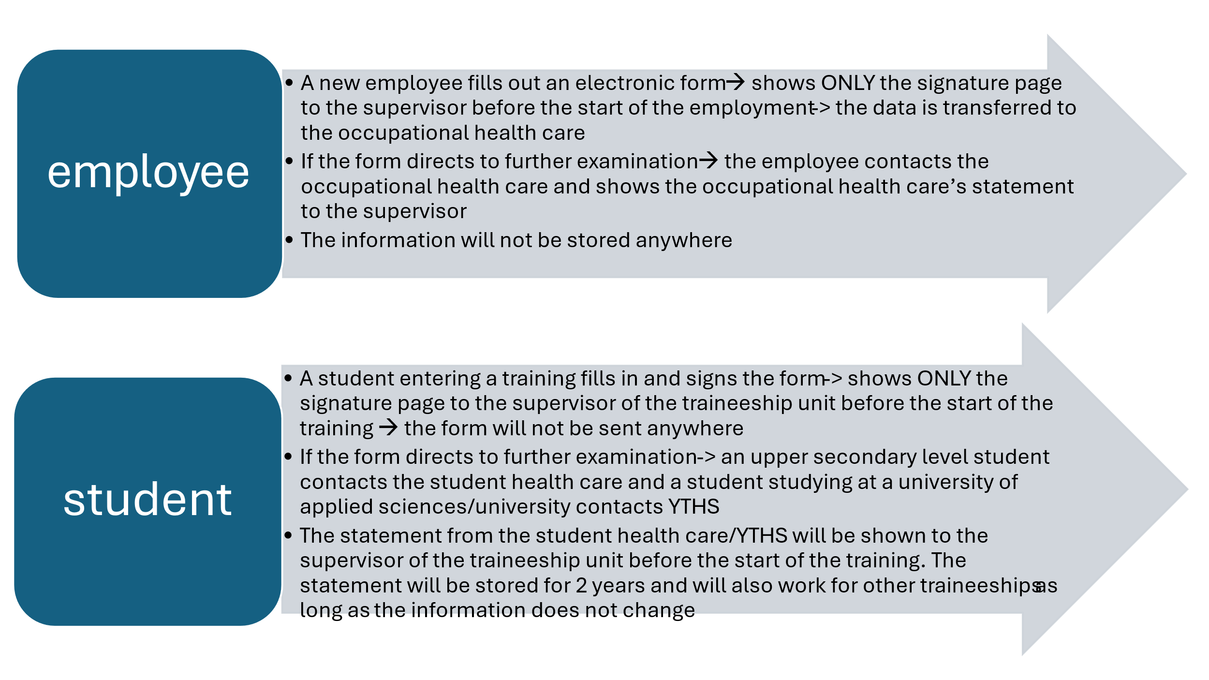

Employee / Student entering a training
Name

Personal identity code | Home phone number
Job title / job description

☐ Employee ☐ Student ☐ Non-military serviceman ☐ Other, please indicate:
The unit you will work/train in

Infection safety report for social and health care personnel
I certify that the information I have given regarding tuberculosis (section 55 of the Communicable Diseases Act) and salmonella (section 56 of the Communicable Diseases Act) is correct. I have read the instructions for the infection control form, and I am aware that I have an opportunity to supplement my vaccination coverage, as recommended and necessary for social and healthcare work under section 48 of the Communicable Diseases Act. I give my consent to occupational/student health service to process and store the above-mentioned information. If any of the above information changes, I shall notify the occupational or student health service without delay.

______ / ______ / _________ _______________________________________________
date employee’s/student’s signature and name in block letters

If, based on the self-assessment form, the occupational or student health service has performed a health check and a lung X-ray, and the suitability for the tasks under section 55 of the Communicable Diseases Act or for the tasks under section 56 of the Communicable Diseases Act has been established: to be signed by the occupational/student health care professional.

Place and date______________________________ Applicable under ☐ section 55 and/or ☐ section 56. Signature of the occupational/student health care professional (job title and name in block letters)

___________________________________________________________________________________

More information, Varha  Länsirannikon Työterveys Oy, tel. 010 325 2200  Turku Student Health Services, tel. 02 266 1570  YTHS, tel. 046 710 1073  Varha Infection Control Unit, tel. 02 313 2431 | More information, Sata-alue  Länsirannikon Työterveys Oy, tel. 010 325 2200  Sata-alue Student Health Services  YTHS Pori, tel. 046 710 1073, Rauma, tel. 046 710 1073  Sata-alue Infection Unit, tel. 044 707 6874

